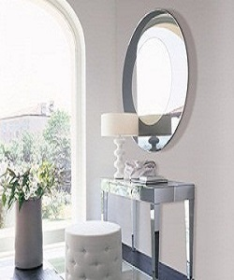

Dressing Table

$143.79

Availability: In stock

Description:

Take a seat in front of this White vanity table and Prepare for the day. Its ravishing appearance will prove to be the perfect addition to your living. Although it looks very humble. Crafted with 2 drawers, includes space to store needed things.